Activity 1.1: Your first Scratch program
Follow these instructions to complete your first Scratch program.
- Go to https://scratch.mit.edu/.
- Select ‘Create’.
- Find the following blocks to make the cat say "Hello [your name]" for 5 seconds. Here is an example:
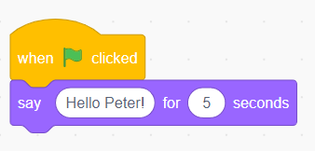
- Press the flag icon to test your program. It should do something like this:
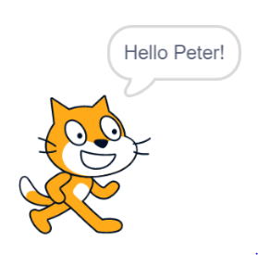
- Now it’s time to save your first Scratch program to your computer. Select ‘File’ and choose ‘Save to your computer’.
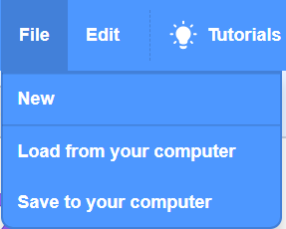
- Let’s practise loading a Scratch program from your computer. Select ‘File’ again and choose ‘Load from your computer’. Select the Scratch program that has been saved and click on ‘Open’.
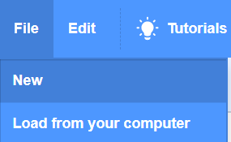

7. Finally, screenshot your blocks and paste the screenshot into your evidence document.
Well done, you have shown you can create a program in Scratch, save it and then open a Scratch program again.

